**Name:** Muhammad Sanawar Khan

**Registration Number:** 2023331

**Q-1**

**(a)**

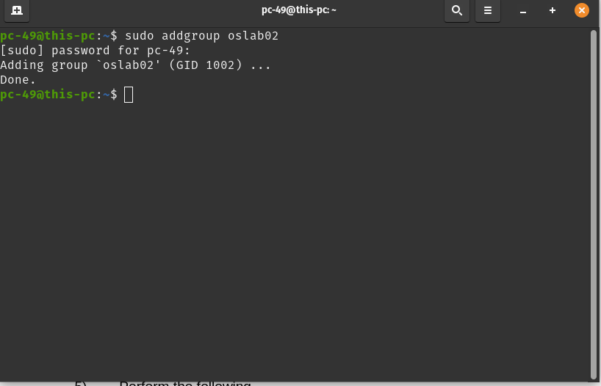

**(b)**

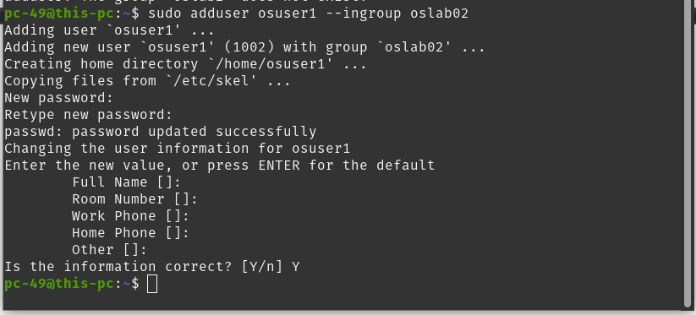

**(c)**

System Restrain

**(d)**

System Restrain

**Q-2**



**Q-3**

**Program:**

#include <stdio.h> // Header File

int main() // Main Function

{

// Print Strings

printf(“I love Operating System”);

printf(“I love Linux”);

return 0;

}

**Output:**

Was denied access although I was using the default account.

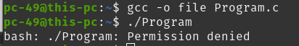

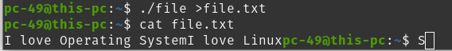

**Q-4**

**(a)**

Created a user already.

**(b)**



**(c)**

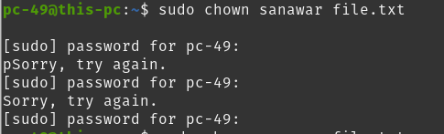

**(d)**



**(e)**



**(f)**



**(g)**



**(h)**

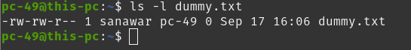

**(i)**

**Script:** sudo find / -name "*lab*" 2>/dev/null

**(j)**

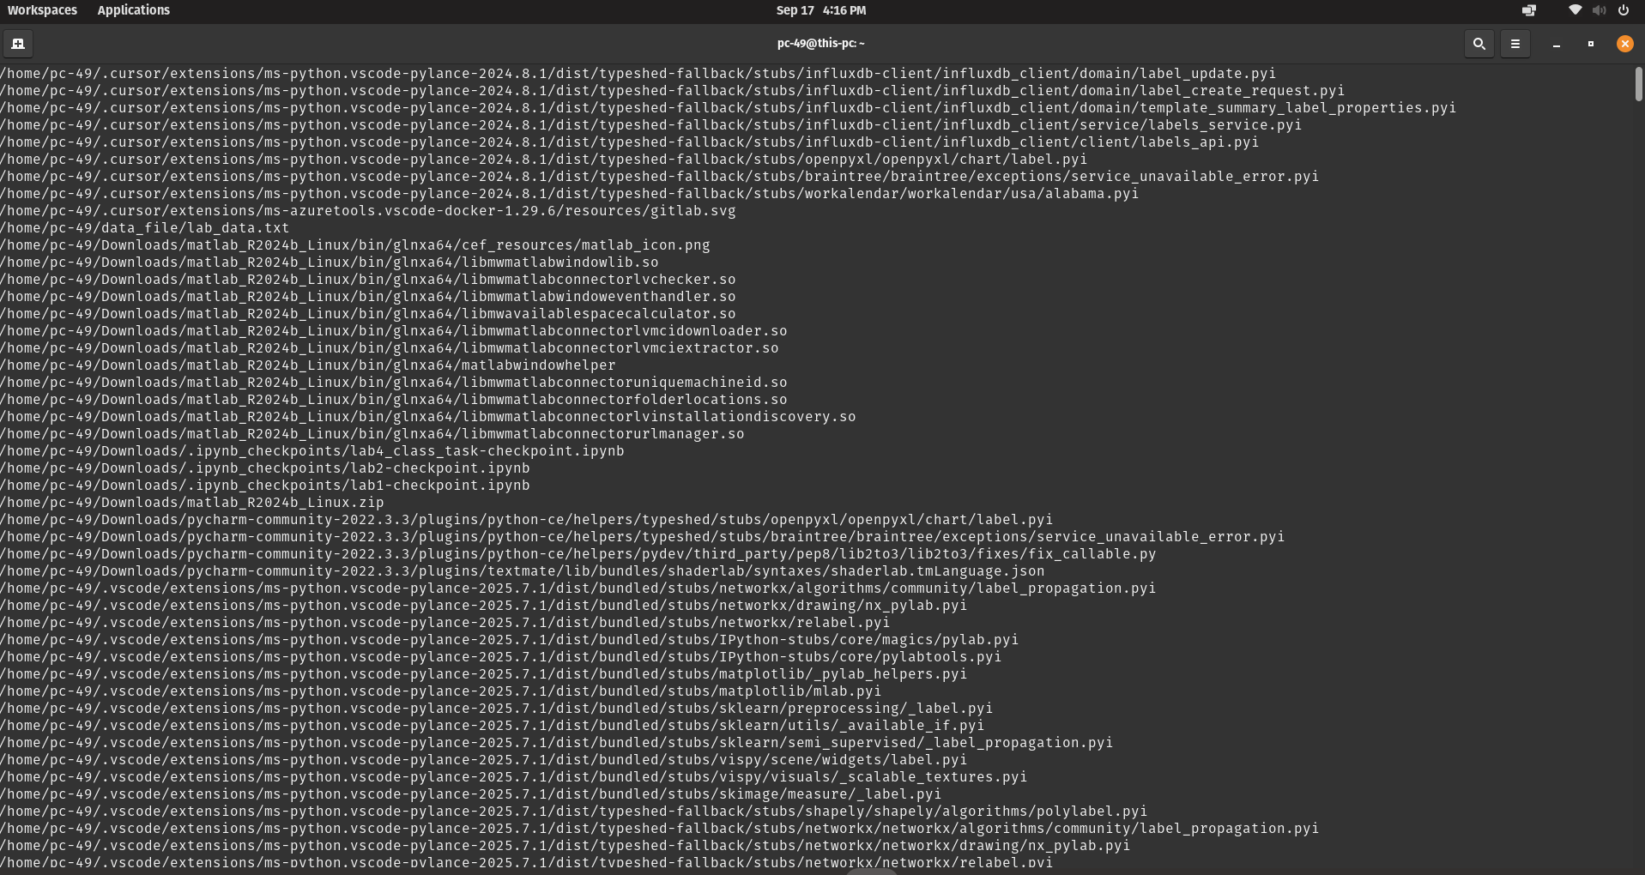

**(k)**

